9/11: Front Page

Examine how different newspapers report the attack on the twin towers on September 11th, 2001. Consider the rhetorical situation (who is the targeted audience, who is the author, and what is the author’s purpose) and bias (whether it be implicit or explicit). Use the guiding questions below, and then fill out the chart for your analysis.

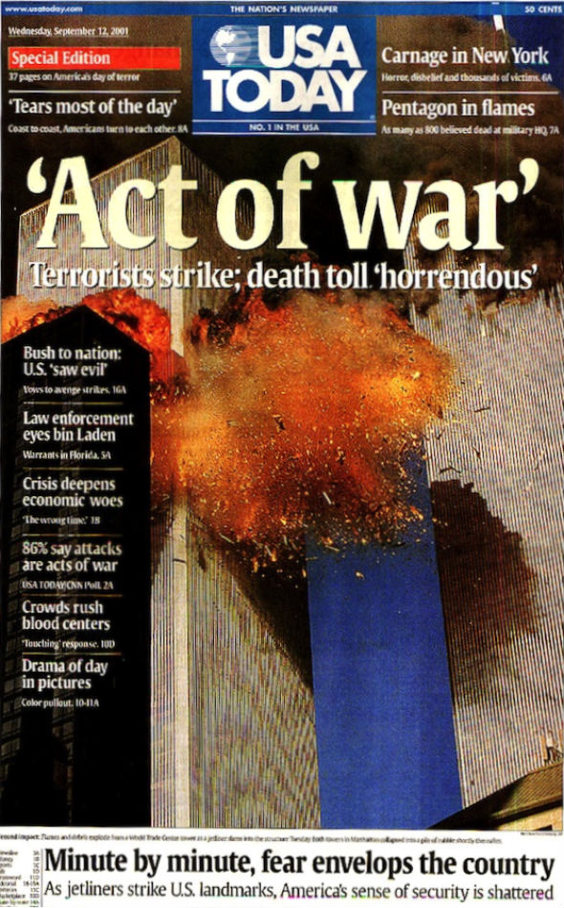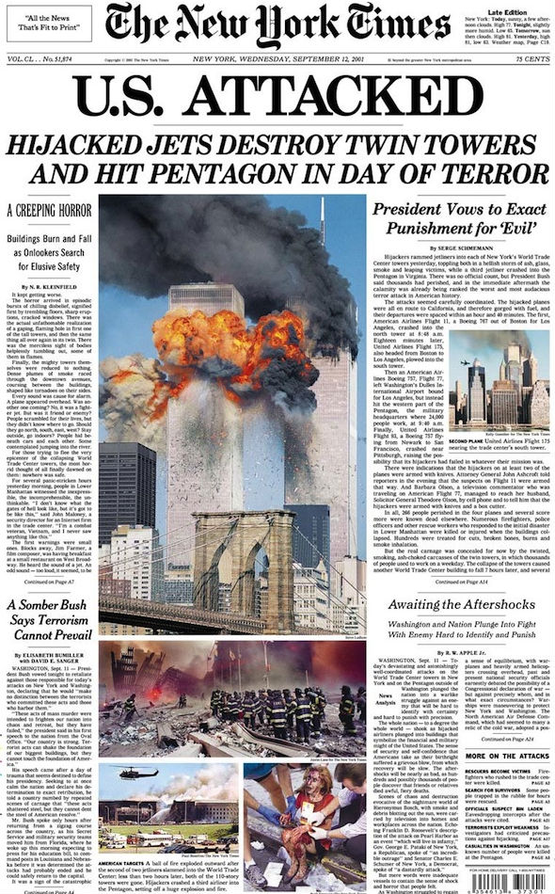

1. Look at the headlines, subheadings, captions and the choice of pictures of two newspapers and compare them. How is language used to create a certain effect?

|  |  |  |
| --- | --- | --- |
|  | Newspaper 1 | Newspaper 2 |
| Headlines | U.S. ATTACKED | ‘Act of war’ |
| Subheadings | Hijacked Jets Destroy Twin Towers and Hit Pentagon in Day of Terror | Terrorists strike; death toll ‘horrendous’ |
| Captions | NA (too small to see) | Minute by minute, fear envelops the country  As jetliners strike U.S. landmarks, America’s sense of security is shattered. |
| Choice of pictures | There are five pictures of different sizes in the newspaper, each describing a different scene: the biggest one is the twin tower on fire, the second is the rescuers in the ruins, the third image is a wounded woman with blood all over, and the other two are still the twin tower at different times and angles. | There is one huge picture that covers the whole page that captures the instant when twin tower was attacked. |

1. Consider how each newspaper works persuasively. How does it appeal to the reader’s sense of pathos (emotions), logos (logic), and/or ethos (credibility)? What response do you think the writer wants to generate in the reader?
2. What biases are reflected in each of the two newspapers you chose? Explain

|  |  |  |
| --- | --- | --- |
|  | Newspaper 1 | Newspaper 2 |
| Layout, Spacing, and Structure (Picture/Text) | * The front page is neatly and compactly organized, with headings, news articles and images. * The headings are all relatively big and capitalized, so that they can easily attract people’s attention. | * The space of the front page is almost taken up by a huge image of the twin tower, with several headlines and subheadings upon. That can easily catch people’s eyes. |
| Headline  (Consider diction and syntax in headline) | U.S. ATTACKED  - the diction can effectively evoke American’ patriotism because their country was being attacked.  - Also, the headline is pretty concise in that there are only two words, and all letters are capitalized. | ‘Act of war’   * The headline uses a metaphor for the whole attack of the twin tower, as it uses a quotation mark. That can easily attract the readers’ attention and arouse their curiosity. |
| Use of Language and intended effect (be specific) | * The headline “U.S. ATTACKED” evokes American’s patriotism. * Phrases like “Day of Terror” and “A creeping horror” can create a terrifying atmosphere, and thus irritate the readers. * Words like “somber” can arouse readers’ sympathy and great grief. | * The language is highly strong and powerful in order to evoke readers’ sympathy as well as the irritation towards terrorists. * The subheading “death toll horrendous” indicates the severance of the event, and thus evokes readers’ fear and anger. * Word choices like “war”, “terrorists”, “death” can cause a terrifying effect on the readers. * Words like “security shattered” can make readers feel unsecured, and thus angrier towards the terrorism and more eager for stricter regulations. |
| How does the front page appeal to the reader?  Pathos / Logos /Ethos | Pathos   * The headline “U.S. ATTACKED” evokes American’s patriotism. * The images, especially the one with a woman covered in blood, arouse readers’ sympathy for victims and indignation towards terrorists. * The word choices like “Day of Terror”, “a creeping horror”, “somber”, “evil”, etc. * All the headlines and subheadings are capitalized, to attract people’s attention as well as to imply the seriousness of the report.   Logos   * The whole front page is logically organized * The headline is really brief and can easily attract readers’ attention; * The subheadings are more descriptive, giving more details of the event. * The layout is composed of both pictures and words of different sizes, so the readers can instantly grab the most important information. Also, in this way, the readers won’t feel too overwhelmed by so many words.   Ethos   * The use of the New York Time itself is very credible, because it is a well-known newspaper. * All the works cited have bibliography. | Pathos:   * Word choices like “war”, “terrorists”, “death”, “horrendous”, “security shattered”, can terrify the readers. * The huge image uses the vivid contrasting colors of red and blue and takes up the whole front page. That can shock the readers in a strong way.   Logos   * The whole front page is logically organized. * The headline is really big so that it can first attract the readers’ attention. It also uses quotation mark, implying it is a metaphor for something terrible * As readers looking down, more descriptive subheadings and captions appear and give readers an overall idea about what the news is about.   Ethos   * The newspaper has valid publisher and publishing date * All the works, including both pictures and articles, are cited. |
| How does each news report reflect a particular bias (either explicit or implicit)?  What can we *infer* about the point of view of the author of each text? | * The newspaper claims that the attackers are terrorists and evils event though it was said that the enemy had not been identified. * Also, some articles in this newspaper has a bias towards the government, and argue that the reason for the attack is the loose national regulation. * The author is probably looking at the event in the view of a common American citizen because of the anger and sympathy showed. | * The newspaper is probably exaggerating the severance and makes a metaphor between terrorists and war. * The author of this newspaper is probably also a common citizen in the US, because he/she is calling the event “act of war”. |

Newspaper 1



Newspaper 2

